
The Course Caps Report
Drafted by the Policy and Resources Department of
Ministry of Academic Affairs 2024-25
Date of Completion of Draft: 04/06/25

Disclaimer
This document serves as a student-initiated report highlighting challenges related to course caps and the pre-registration system in Ashoka. The experiences and access to courses vary across programs and semesters. Therefore, readers are encouraged to interpret the data and analysis within this broader context. The insights presented are based on survey responses and reflections from over 500 students across disciplines and years, compiled by the MAA.
This report is not an official policy document and does not represent the views of the university administration. The MAA is not responsible for any institutional decisions or outcomes resulting from interpretations of this report. The policy suggestions included are intended as recommendations only. We invite readers to engage with this report as a contribution to ongoing dialogue and to consider its findings alongside other relevant perspectives.
Drafting credits: Anushka Sinha, Gargi Deshpande, Mehati Punnamaraju, Minal Priya, Shranya Gupta, Navvya Rahate and Umang Chauhan.

Flow of the Report:
- Introduction
- Objectives of this Study
- Key Hypothesis
- Methodology
- Data Analysis: each hypothesis has been tested against quantitative and qualitative data, with inferences mentioned of each
- Policy suggestions by the MAA team to tackle systemic issues around course caps
- Limitations of this study and Scope for Future Research
- Appendices

1. Introduction
The course-cap report is an initiative by the Ministry of Academic Affairs 2024-25. This report aims to explore the asymmetry between the number of seats available in a course with respect to their demand, more specifically, the issues arising from lower course caps and the higher demand for them. While course-cap concerns have been raised informally in the past few years, recent registration cycles have suggested that these supposed limitations may be systematic, calling for an institutional-level analysis. By consolidating data and experiences, this report aims to present quantitative and qualitative evidence for possible policy-level changes.

2. Objectives of the Report
- To empirically establish the scope and chronology of the course cap issue using data from over 500 student responses from Spring semester 2025.
- To examine communication gaps between the Board of Representatives, the OAA, and the student body.
- To identify structural, pedagogical, and resource-related constraints limiting a blanket increase in course caps.
- To propose policy recommendations informed by data and student feedback.
- To analyse the impact of course caps on academic progression, mental well-being, and course planning across cohorts and disciplines.

3. Key Hypotheses
We hypothesise that the course cap issue is systemic and:
- The current pre-registration system does not effectively translate student demand into course cap increases and often fails to reflect true demand.
- Course cap issues affect academic trajectories, sometimes forcing students to change their majors or minors due to course unavailability.
- Students’ academic trajectories may be affected by increased workload when they cannot enrol in introductory courses and must take higher-level electives instead.
- Course caps increase academic stress and uncertainty, negatively affecting student well-being.
- Constraints such as limited infrastructure and faculty resources hinder a blanket increase in course caps despite growing student numbers.

4. Methodology
To validate the issue, we conducted both quantitative and qualitative research

4.1. Quantitative Data

4.1.1. Data collection and methodology
- The quantitative data for the report is derived from a survey. The survey was conducted through Google Forms. It was circulated to the entire student body through email, meaning every student had equal access to the Google Form.
- The data was calculated through simple manual mathematical calculations and Google Form statistical analysis.

4.2. Qualitative data

4.2.1. Data collection and methodology
- The qualitative data is derived from the Board of Representatives–the student representatives for each department.
- Another Google Form made specifically for the representatives was sent to them. This Google Form was to be answered in their capacity as the representative for their department, for their observations and experiences for both the monsoon and spring semester in the academic year 2024-25.

5. Data Analysis

5.1. Overview of Variables
Variable | Description / Purpose
Student Year & Academic Profile | Records batch, majors, minors, and concentrations to identify group trends.
Courses Missed Due to Caps | Identify courses where students were unable to enroll due to course cap restrictions.
Type of Courses Missed | Classifies missed courses as Introductory, Core or Elective courses.
Impact on Academic Trajectory | Assesses delays, forced higher level electives, or changes in academic plans.
Impact on Academic Performance & Well-being | Captures stress, anxiety, and decline in academic performance as a possible result.
Student Strategies & Institutional Support | Examines coping methods such as waitlists, contacting reps/OAA, or course abandonment.
Structural and Scheduling Conflicts | Identifies recurring timetable clashes and interdisciplinary registration issues.
Perceived Causes of Course Cap Issues | Records student perceptions of barriers like faculty choice of class size, infrastructural limits, or certain policies.
Student-Suggested Solutions | Collects student proposals to inform policy recommendations.

5.2. General Findings (Appendix III-XIII)
- A majority of affected respondents were from UG2024 (55.3%), followed by UG2023 (23.8%), UG2025/26 (15.3%), and ASP students (4.8%).
- Course Cap Issues: 93.2% of students faced difficulties registering for courses due to course caps.
- Academic Delay: 38.2% of students reported a one-semester delay in their academic trajectory, while 11.7% experienced a delay of two semesters.
- Mental Health Impact: 64.1% of the students reported that their well-being was significantly highly affected by course-caps.
- Timetable Clashes: 90.9% encountered scheduling conflicts, especially between FCs and departmental courses.

5.2.1 Coping Methods
- 57.8% took alternative courses in the same department.
- 48% got waitlisted and did not get the course.
- 46% got waitlisted and got the course later.
- 33.8% requested the professor for an override.
- 3.8% dropped the course for the particular semester.
- 29.3% took the course in a later semester.
- 43.7% took other courses from their minor/concentration/FCs.
- 37.1% switched to another course during registration itself because of pre-registration numbers.

5.3. Hypotheses Analysis

5.3.1 Hypothesis 1: The current pre-registration system does not effectively translate student demand into course cap increases and often fails to reflect true demand.

5.3.1.1. Quantitative Analysis
- 20% of the students reported that they did not get a course even though they had pre-registered for it.
Note: We are aware that the limit to pre-register is more than the limit to register in courses, since it might show an inflated figure, however the 20% figure is still relevant as it may include both students who had pre-registered in a course as first and second priority.
- 14.8% of the students said that seniors got course seats without pre-registering, which caused students who had pre-registered to lose their spots.
- Only 6% of the students noticed any changes in seat numbers or new course sections based on pre-registration demand.
- 12.8% of the students experienced crashes or major technical problems with the AMS platform during registration.
- 45.8% of the students ended up taking higher-level courses in order to fulfill their course requirements.
- 37.1% changed their planned courses just because they expected certain courses to be crowded or capped, based on pre-registration trends.

5.3.1.2. Inference

- The data indicates that the pre-registration system is ineffective as a tool for accurately mapping student demand. Course caps are infrequently adjusted in response to pre-registration interest, and most departments do not revise seat allocations accordingly.
- Almost 15% of students reported being displaced by seniors who had not pre-registered, which makes the process unfair and makes early course planning pointless, especially for first-year students.
- One in five students who pre-registered for a course still did not get in, thereby defeating the fundamental purpose of the pre-registration system.
- Technical problems, like AMS crashes, affected 12.8% of students and added more uncertainty and unfairness to an already difficult process.

Overall, the pre-registration system currently does not provide much real help to students. It fails to serve its primary objective which is to gauge student interest and increase or decrease seats accordingly. It does not affect seat allocation in a meaningful way, does not prevent students from losing seats unfairly, and does not ensure fair access.

5.3.1.3. Qualitative Analysis

5.3.1.4. Evidence
- No department directly attributed course cap issues to the pre-registration system itself; however, departments such as Biology, PPE, and Philosophy exhibited patterns where student demand could have been anticipated based on pre-registration data.
- Chemistry and History departments responded by increasing course caps accordingly, while others did not adjust caps despite similar signals.

5.3.1.5. Inference
- The core issue appears not to be with the pre-registration system itself, but rather with how departments interpret and act on pre-registration data. While some departments proactively adjust course caps based on pre-registration trends, others face additional constraints that prevent them from responding effectively, which we will discuss ahead.

5.3.2. Hypothesis 2: Course caps affect academic trajectories, sometimes forcing students to change their majors or minors due to course unavailability.

5.3.2.1. Quantitative Analysis
- 93.2% of the students reported difficulty in securing desired courses.
- Among the courses students couldn’t access due to cap limits, 82.4% were introductory, and 50.7% were Foundation Courses (FCs).
- 38.2% of the students had their academic trajectory delayed by 1 semester.
- 11.7% of the students faced delays of 2 semesters.
- 60% of students who reported experienced some form of trajectory disruption, with 10% changing their major/minor.
- 57.8% of the students enrolled in alternative courses within the same department.
- 45.8% reported taking higher-level courses.
- 43.7% opted for courses from their minor instead.
The most affected departments were:
- Psychology (30%)
- Second one is under analysis currently.
Both departments struggled with strict course caps.

5.3.2.2. Inference
- The data indicates that course caps significantly disrupt academic trajectories and are a widespread problem affecting a majority of students. Foundation and introductory courses, which are critical for progression, are frequently unavailable, causing delays that extend graduation timelines and increase student stress.
- About 10% of students said they had to change their major or minor because they couldn’t get the courses they needed, reflecting the seriousness of the problem and compromise of academic freedom.
- Departments like Economics and Psychology are hit hardest because their introductory courses are prerequisites for higher-level classes, so missing even one course can prevent students from enrolling in several others later, making it much harder to stay on track.
- Second-year students are especially affected, highlighting a critical challenge during an important stage of their academic planning.

It can be concluded, therefore, that current course caps on foundation courses and core introductory/gateway courses not only hinder short-term academic scheduling but actively shape long-term student decisions, including changing majors or minors. The data reveals that this is not a marginal occurrence, but a systemic issue with measurable impacts.

5.3.2.3. Qualitative Analysis

5.3.2.4. Evidence
- PPE & Bio: Reps mention students missing core courses or lab slots.

5.3.2.5. Inference
- Lack of access to the gateway courses could discourage students from staying in their intended discipline.
- Students may opt for departments with easier access rather than true interest.

5.3.3. Hypothesis 3: Students’ academic trajectories may be affected by increased workload when they cannot enroll in introductory courses and must take higher-level electives instead.

5.3.3.1. Quantitative Analysis
- Around 45.8% of 517 students reported taking higher-level courses from the same department to fulfill major requirements due to unavailability of seats in core courses.
- Of the 150 students who provided further details about their academic focus(es):
  - 45.3% were pursuing Psychology.
  - 22.7% were in English (including interdisciplinary majors with Creative Writing and Media Studies).
  - 21.3% were in International Relations.
  - 20.7% were in Entrepreneurship.
  - 19.3% were in Biology.
  - 15.3% were in Political Science.
- Among students who took higher-level courses:
  - 44.6% reported that this negatively impacted their academic performance and grades.
  - 29.5% said it did not impact their academics.
  - 25.9% were neutral regarding the impact on their performance.

5.3.3.2. Inference
- Students in saturated majors, like Psychology, IR, etc. frequently cannot enroll in introductory courses due to seat shortages.
- These students resort to taking higher-level courses, which negatively affects grades, understanding of course material, quality of participation in discussions, and creates persistent knowledge gaps.

5.3.3.3. Qualitative Analysis

5.3.3.4. Evidence
- 5 of 12 Board of Representatives reported consistent oversubscription of core courses, especially in Political Science, PPE, and International Relations.
- Political Science core courses are hard to access even for second-year students, and these are prerequisites for many electives; similarly, International Relations’ core courses and PPE’s Economics and Political Science cores face high demand.
- The Political Science representative noted that students often take electives first and defer core courses to later semesters, as electives are generally available except for cross-listed or high-demand courses.

4.3.3.5. Inference
- Oversubscription of core and foundational courses disrupts academic progression, forcing students to take higher-level electives or unrelated courses.
- This leads to delays in required course access, potential overload in later semesters, or changes in academic plans (majors/minors).

5.3.4. Hypothesis 4: Course caps increase academic stress and uncertainty, negatively affecting student well-being.

5.3.4.1. Quantitative Analysis
- 64.1% of the students reported that their well-being was significantly/highly affected by course-caps.
- 30.9% of the students reported that they were slightly/moderately affected by course-caps.
- 53.19% of the students implied or mentioned facing moderate to high anxiety/stress during pre-registration and/or registration period.
- 55.4% of the students reported facing difficulty in fulfilling their major/minor requirements due to credit requirements and maximum course limit per semester.
- 45.8% of students reported taking a higher-level course in order to fulfill their course requirements.
The above data showcases the impact of course-caps on the student body. 95% of the student body reports in course-caps influencing their well-being in varying degrees. This stress is seen in both short-term and long-term effects.

5.3.4.2. Inference

Short-term effects
- The short-effects are seen during the period of course registration and pre-registration where 53.19% people mention experiencing moderate to high stress/anxiety.

Long-term effects
- The long-term effects can be inferred from the data relating to course trajectories.
- 60% of the respondents mention course-caps impacting their trajectory.
- 38.2% reported that the impact lasted for a semester, whereas 11.7% of the students reported its impact lasting for two semesters.
- Another long-term impact is seen in the replies of 55.4% of the students who state that they are facing difficulties in completing their major/minor requirements due to credit requirements and maximum course limit per semester.

5.3.4.3. Coping with effects
- In order to complete course-requirements, 45.8% of respondents mention taking higher level electives.
- Out of these 45.8%, 44.6% mention this decision affecting their academic performance.
Choosing a higher-level course leads to both short-term and long-term effects. The short-term effects can be seen in the adverse impact on grades. However, in the long-term, effects may be seen in the overall learning outcomes.
From the data above, it can be inferred that current course-caps led to an increased uncertainty while planning for trajectories. This uncertainty is translated into widespread anxiety and stress, impacting student well-being.

5.3.4.4. Qualitative Analysis

5.3.4.5. Evidence

PPE, Philosophy, Biology: Introductory and core courses oversubscribed.
- Biology: Limited lab access due to resource and scheduling issues.
- PPE: Certain electives aren’t repeated, so students who miss them feel pressured.
- General trend: Multiple departments mention students missing courses due to limited capacity or cross-listing demand.

5.3.4.6. Inference
- Repeated oversubscription increases academic anxiety.
- Fear of missing crucial courses creates unnecessary stress during registration.
- Students are left uncertain about completing degree requirements in time.
5.3.5. Hypothesis 5: Factors preventing blanket increase in course caps might be lack of infrastructure, faculty discretion on class size, increasing batch size with relatively constant numbers of faculty, among others.

5.3.5.1. Quantitative Analysis
- 83.9% of students identified classroom capacity as a primary reason preventing increased course enrollment caps.
- 86.5% of students cited lack of faculty as a barrier to expanding course capacity.
- 51.9% of students believe that increasing faculty numbers is the solution to enrollment capacity issues.
  - Of these students, 72.7% specifically identified the Psychology department as needing additional faculty members.
- For the Economics department, students prioritized grading standardization over faculty increases, with only 17.8% advocating for increased Economics faculty.

5.3.5.2. Inference
- Infrastructure limitations and faculty shortages are the primary bottlenecks preventing universities from accommodating growing student demand through increased course caps.
- Students recognize department-specific solutions, with Psychology requiring more faculty while Economics needs standardized grading practices to manage larger sections effectively.

5.3.5.3. Qualitative Analysis

5.3.5.4. Evidence
- 25% of the interviewed Board of Representatives mentioned that the issue lied in the lack of infrastructure.
- 33.33% of the interviewed representatives mentioned that the faculty was reluctant to teach larger classes due to the potential loss of learning outcomes, critical engagement and student discussion.
- One representative mentioned that their department faced an issue due to a lack of classrooms to accommodate the class size.
- This was a concern for subjects with lab work, as enough labs do not exist to accommodate the amount of students.
- The Visual Arts department also faced a similar issue as the studio does not have enough space to accommodate a larger batch.

5.3.5.5. Inference
      - Structural constraints rather than administrative policy primarily limit course capacity expansion, with both physical infrastructure and human resources creating bottlenecks.
      - Faculty resistance to larger class sizes reflects legitimate pedagogical concerns about maintaining educational quality, particularly in discussion-based disciplines like Political Science and International Relations.
      - Department-specific approaches are needed, as different disciplines face distinct challenges in scaling course delivery while preserving academic standards.

5.4. Other Findings:
- 29 responses highlighted concerns over inadequate communication and transparency from the OAA regarding course caps.
- 19.3% of students raised pedagogical concerns about increasing course caps, citing issues such as reduced quality of class discussions, limited individual attention, and diminished learning outcomes.

6. Policy suggestions

6.1. AMS Enrollment Priorities,
To support timely academic progression, we propose reserving a fixed percentage of seats in gateway courses for first and second-year students who require these to advance in their intended majors. While some may raise concerns about limiting academic freedom or restricting access for upper-year students, this policy does not intend to exclude anyone entirely. It establishes reasonable priorities to ensure that students who need these gateway courses earliest have access, while upper-year students remain eligible to register for remaining seats and still get priority as their registration happens before. This policy balances fairness and flexibility, promoting efficient resource use while respecting students’ academic choices.

6.2. Course caps should be determined based on pre-registration demand and historical enrollment data.
Course caps should be set using a combination of pre-registration demand and historical enrollment patterns. High numbers of pre-registrations signal strong student interest, while past enrollment data help identify consistent trends of over- or under-enrollment. By aligning course capacities with these insights, we can better match supply to actual demand, minimizing unnecessary waitlisting and avoiding underutilization of teaching resources.
Departments, like several of them already do, should maintain reports of seat allocation of each semester to be able to use that data if the course gets repeated again.

6.3. Increasing number of sections
If pre-registration demand exceeds capacity, additional sections should be added to accommodate more students and reduce waitlists, ensuring better access without lowering instructional quality.

6.4. Offering more electives with fewer or no prerequisites.
Offering more electives with fewer prerequisites provides students greater flexibility. This allows them to progress in their major, minor, or concentration even if they cannot enroll in a specific introductory course.

6.5. Prerequisite waivers via testing

In cases where students couldn’t enroll in an introductory or core course, they may take a test to demonstrate their knowledge. Passing this test would allow a fair waiver of the prerequisite, enabling academic progression without delay. This waiver does not exempt students from eventually completing the required course; it only ensures they meet the necessary standards to continue their studies on time.

6.6. Minimum Course Cap (Course Cap Floor) Based on Historical Data
Each course should have a minimum seat capacity to accommodate more students from the start. Exceptions may apply for lab or studio courses where space and resources are limited. This helps reduce waitlists and better meets student demand. This of course has to be balanced with faculty discretion first.
For example, if a popular Political Science course consistently sees over 50 students trying to enroll but has a seat cap of only 30, this leads to long waitlists and delays in academic planning. Setting a reasonable minimum cap, such as 50 seats, for such high-demand courses would better reflect student interest.

6.7. Offering High-Demand and Introductory Courses Across Semesters
The majority of introductory courses are currently only offered in the Spring semester. This could delay a student’s academic trajectory by two semesters if they do not get an introductory course in one Spring semester. To address this, the administration can survey students to identify which introductory or core courses are in high demand and prioritize offering those across semesters. Thus, introductory courses can be offered in the Monsoon and Summer semesters, along with the Spring semester, so that there are minimal delays in trajectory.

6.8. Reducing Scheduling Conflicts Across and Within Disciplines
Timetable planning should be better coordinated across departments to reduce clashes, particularly in interdisciplinary programs. For instance, English and Media Studies courses, despite being part of an interdisciplinary major, often overlap, restricting students’ ability to fulfill requirements. Even within a single department like Psychology, core courses are frequently scheduled in the same time slots (e.g., 11:50–1:20), making it difficult to take more than one required course per semester.
Additionally, departments with overlapping student bases, such as Economics and Entrepreneurship, should coordinate their schedules to avoid unnecessary conflicts. For example, if an Economics course has two sections but one of them overlaps with a required Entrepreneurship course, students enrolled in both programs will be forced to crowd into the single available section. This creates uneven demand, leads to oversubscription, and reduces overall access. By scheduling such departments' core courses in non-overlapping time slots, more students can be accommodated across sections, easing pressure on individual classes and allowing for more balanced enrollment.
We understand that this may be difficult to coordinate and also depends on classroom and faculty availability. However, student reps can be asked to help to gauge such student patterns to ease the process at least to some extent.

6.9. Reservation for Critical Academic Situations (Professor's Discretion)
A small portion of seats should be reserved for students in critical situations, such as those who missed core courses consistently due to past caps, are returning from leave, or face delayed graduation without this course. These seats, allocated at the professor’s discretion, ensure students can meet essential requirements without affecting general seat availability.

6.10. Strengthening Infrastructure
83.9% students highlighted that limited classroom space, inadequate lab facilities, and a shortage of teaching fellows contribute significantly to course cap problems. Insufficient infrastructure restricts the number and size of sections that can be offered and strains faculty resources, directly impacting the availability of seats.
As a temporary solution, some students suggested offering more Friday and Saturday classes to make better use of available classroom space. While not ideal for everyone, this could help expand course offerings in the short term.
In the long term, information on how classrooms and labs are being used, as well as the number of TFs compared to students, should guide the planning and improvement of these resources. Improving infrastructure, adding more classrooms, lab spaces and visual and performing art spaces is important to keep up with growing student numbers and to provide a better learning experience.

6.11. Faculty Expansion as per the Demand
51.9% students suggested that faculty should be recruited in proportion to student intake, enrollment trends, and the growth of prospective majors within each department. Data on historical enrollment patterns and preference lists should guide hiring decisions to ensure sufficient teaching capacity.
As a temporary solution, students recommended increasing the number of teaching fellows (TFs) and student teaching assistants (TAs), as well as offering smaller discussion sessions. These measures could help manage class sizes, improve student support, and reduce pressure on faculty while longer-term solutions are worked on.
Ensuring adequate faculty numbers is essential to maintain instructional quality, offer timely courses, and accommodate increasing student demand without compromising academic standards.
Note: There exists a preference problem regarding the course-caps in the Economics department from the student end as well. Economics students reported in the ‘policy suggestions’ section that core course professors are chosen based on grading leniency, where lenient professors have more pre-registrations, leading to the section being oversubscribed while sections with other professors for the same course remain undersubscribed.

Limitations and Scope for Future Research
While this report presents key insights into student experiences and concerns regarding course caps, it is important to acknowledge its limitations. We had initially intended to incorporate a broader range of data points, including historical enrollment data from the AMS portal and interviews with ASP students. However, our efforts in securing interviews with ASPs saw limited success. Additionally, we would have liked to engage more extensively with Heads of Departments, faculty members, and administrative offices to better understand the rationale behind course capping and related logistical considerations. As such, this report is primarily based on student responses and inputs from the Board of Representatives. Despite these constraints, we believe the perspectives captured in this 4000-word report are meaningful and valuable in guiding initial conversations. That said, we recognize there is considerable scope for deeper institutional research and dialogue. We hope that future student leaders will build upon this groundwork and take the conversation forward in more comprehensive ways.

Appendices
Appendix I
Course cap BoR form:
https://docs.google.com/forms/d/e/1FAIpQLScIbjo7GaBTlV5Tl_aZC5jYpLLaM2y-HDyep9RmpYo2c3bSaw/viewform?usp=dialog
Appendix II
Course cap student form:
https://docs.google.com/forms/d/e/1FAIpQLSeIl_mmWG3Ku9Axrg7iBaDDelFBk5X4t_xDQnTTS9elvhh2KQ/viewform?usp=dialog
Appendix III
Batch responses:
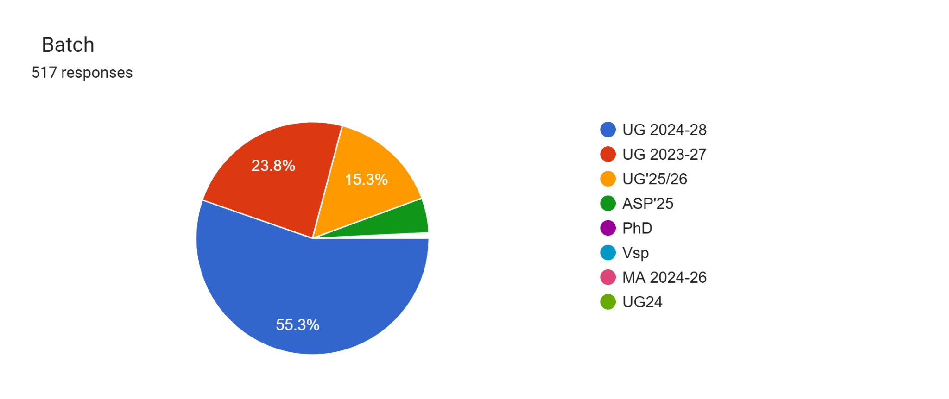
Appendix IV
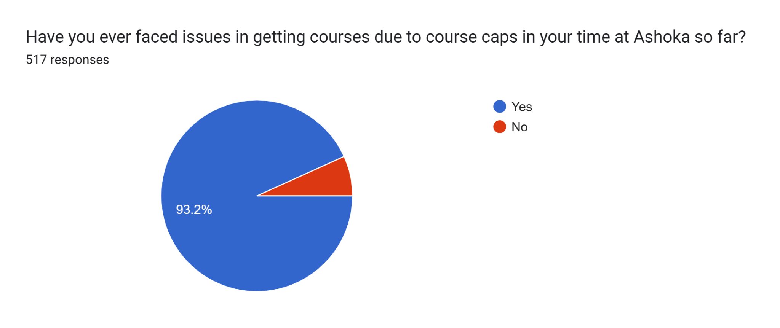
Appendix V
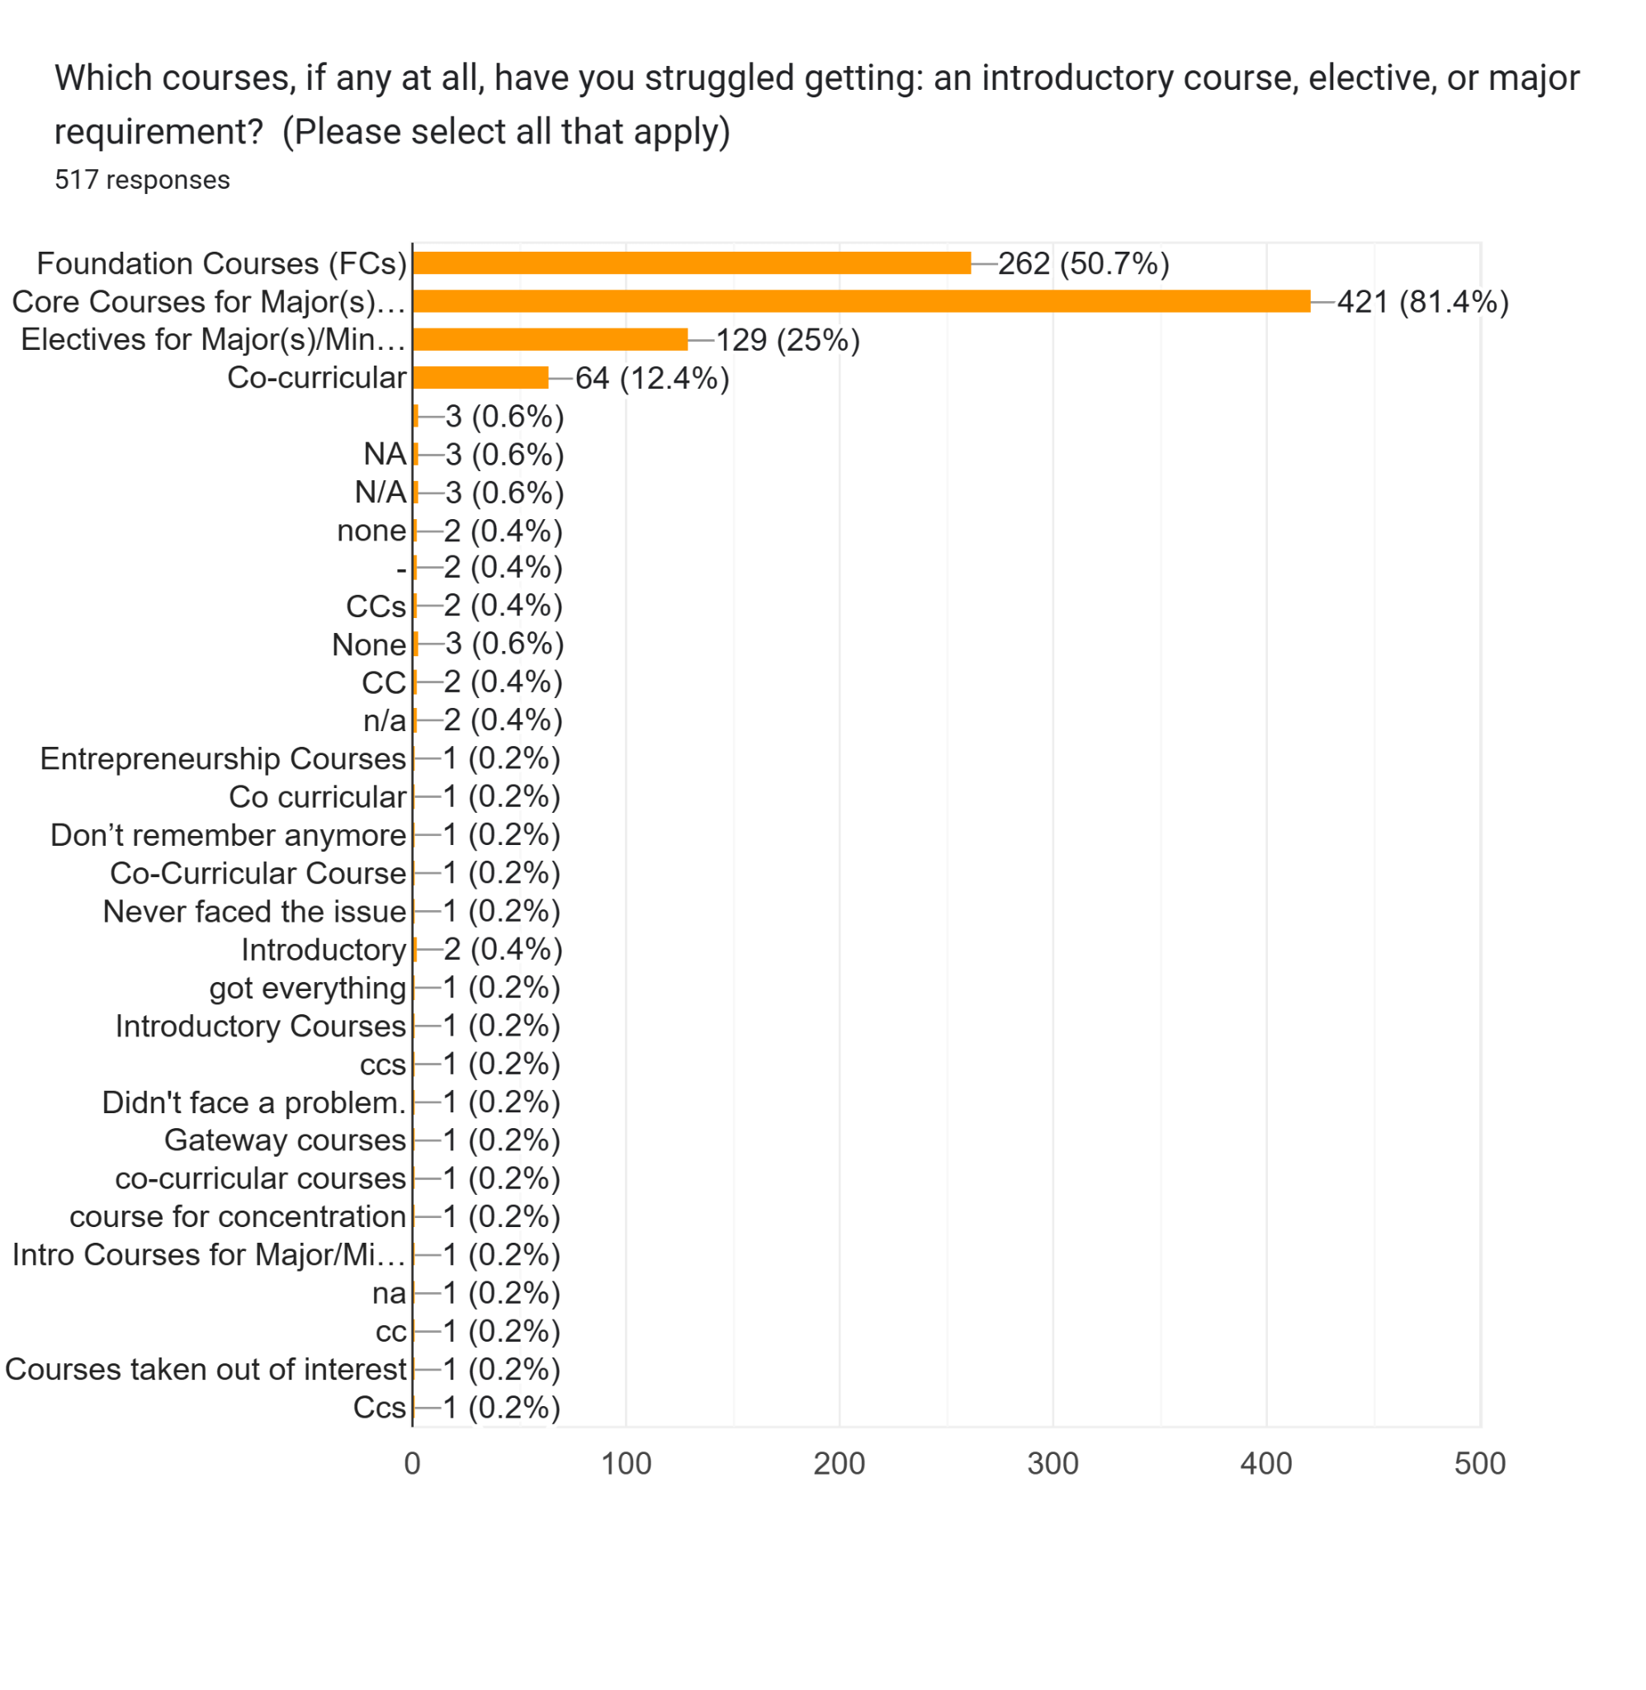
Appendix VI

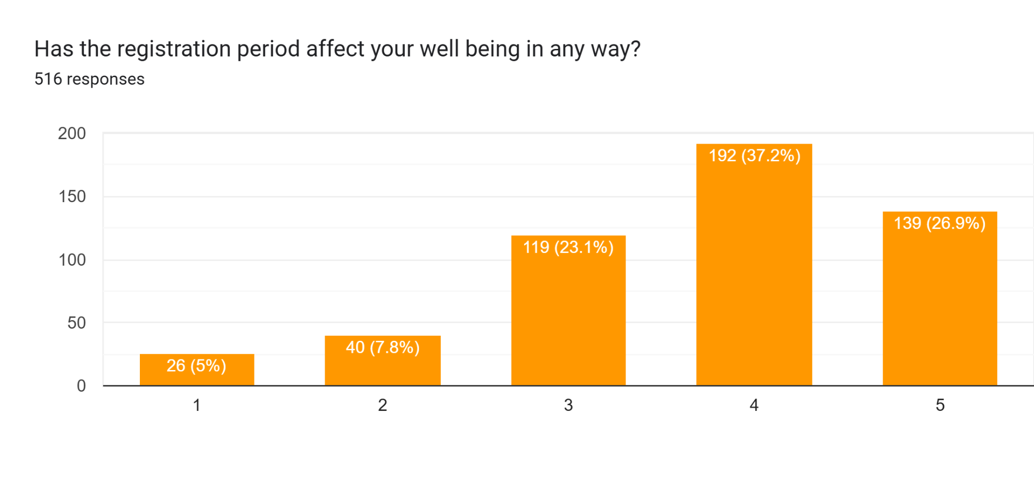
Appendix VII
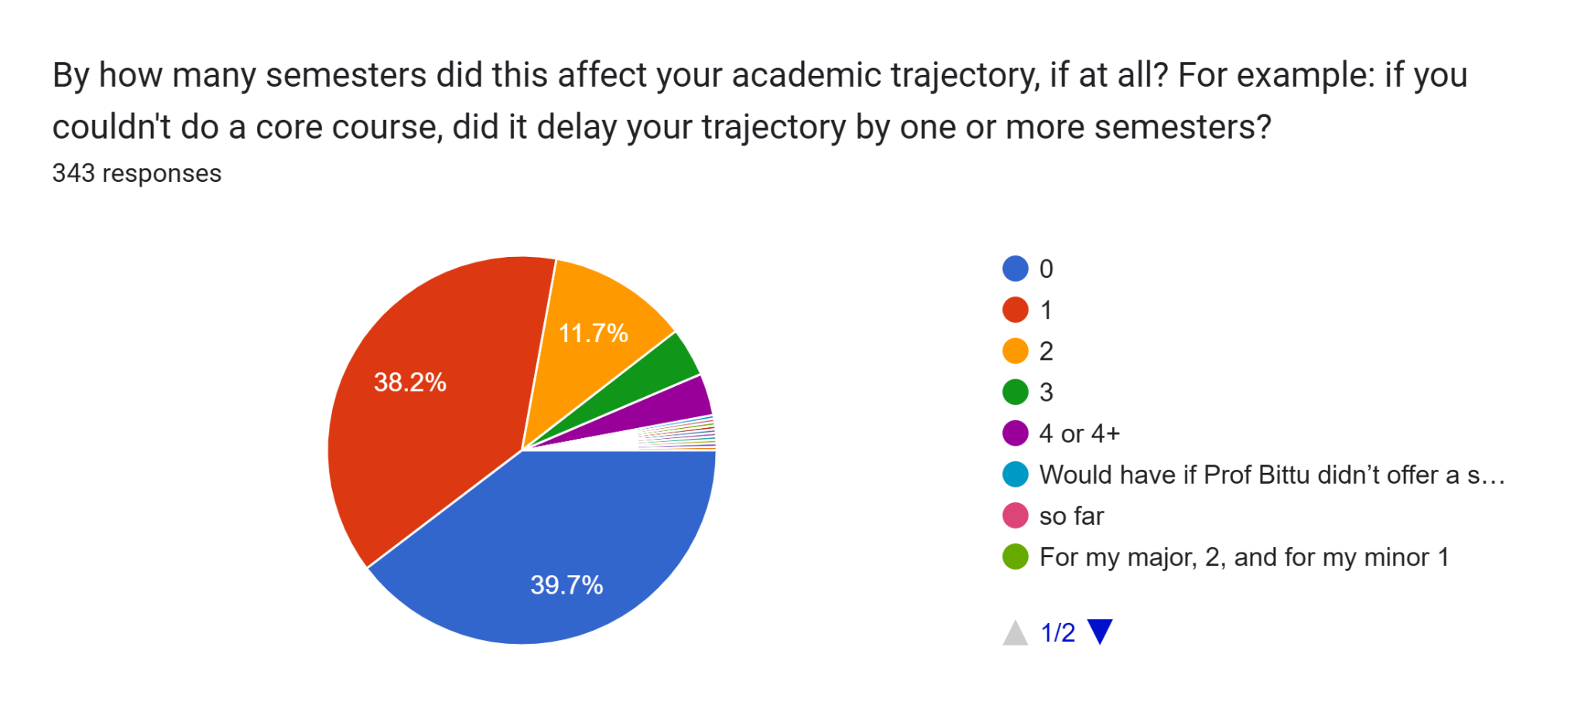
Appendix VIII
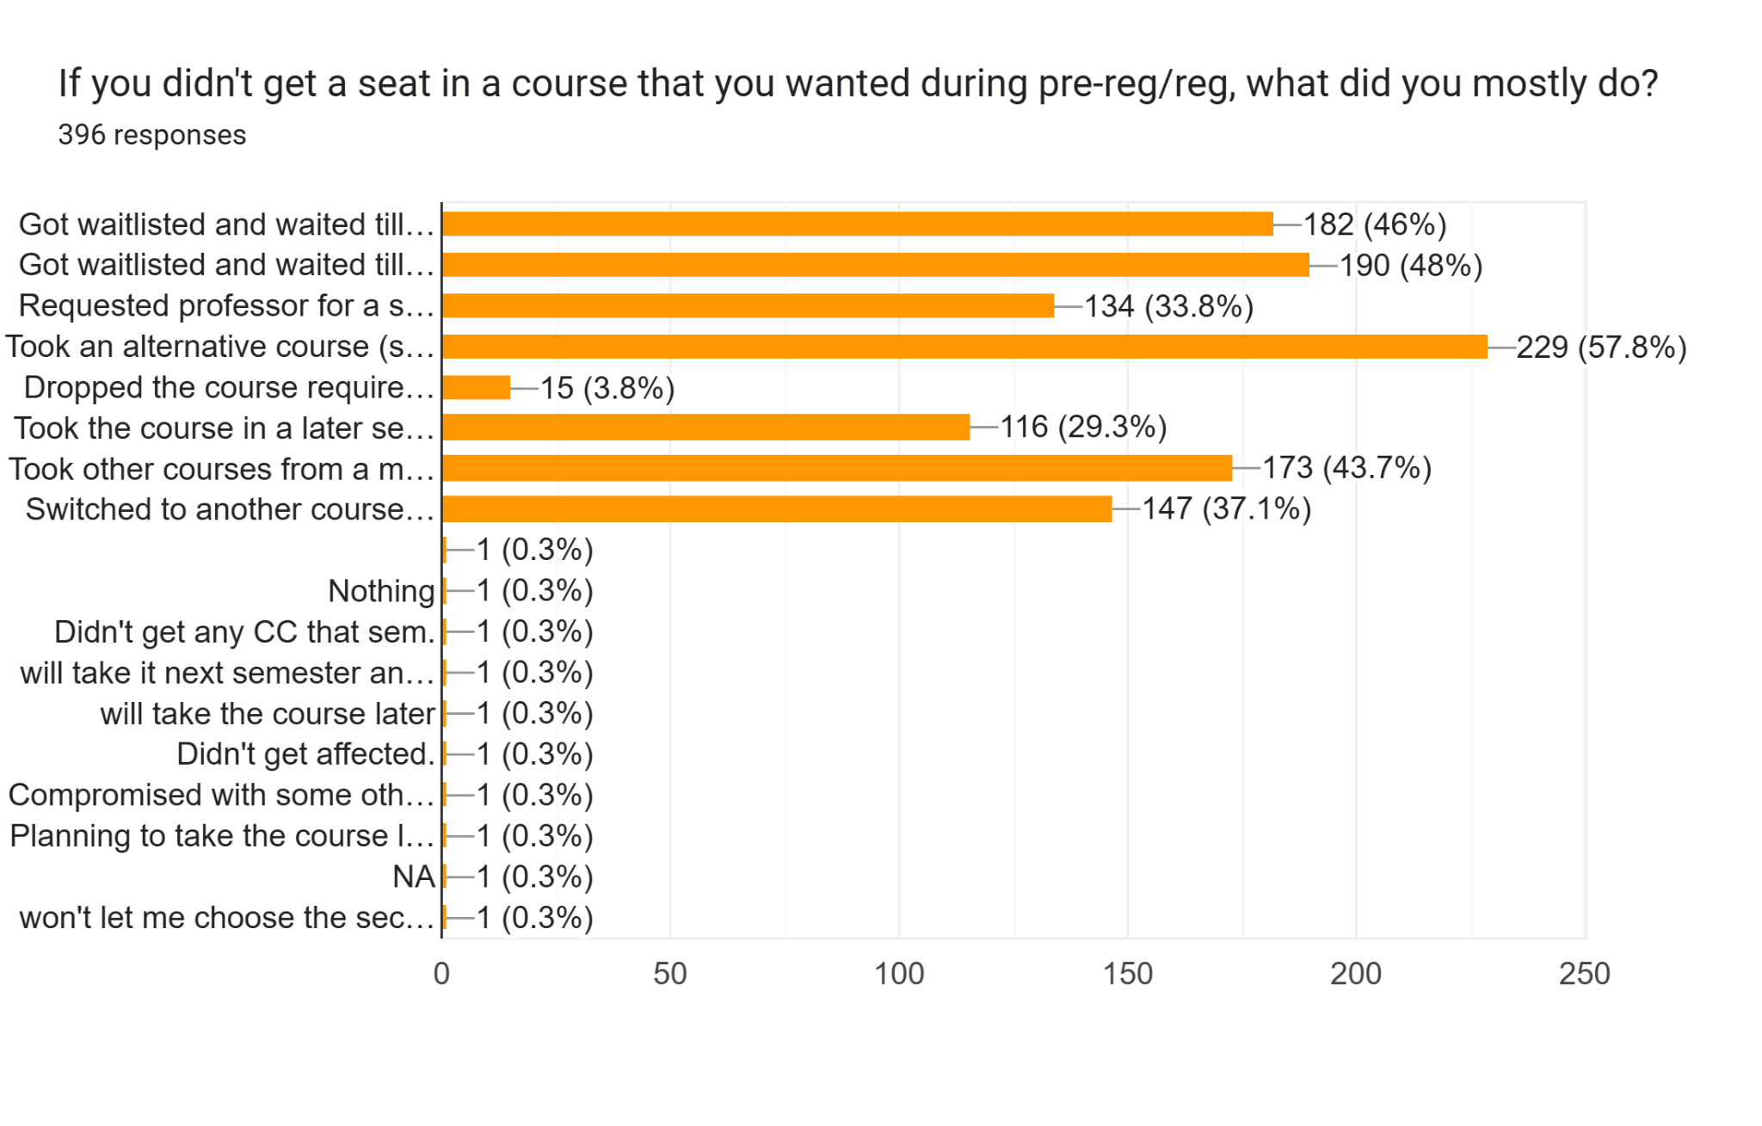
Appendix IX
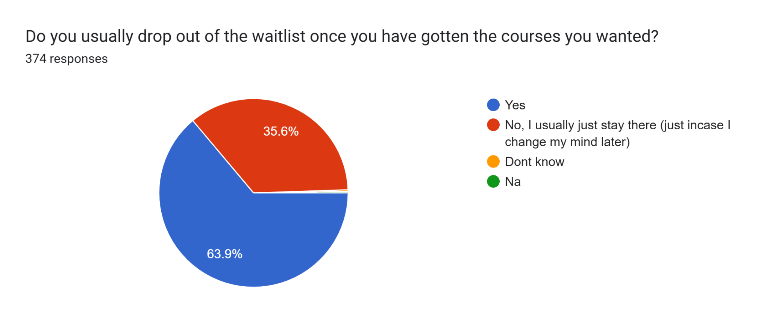
Appendix X
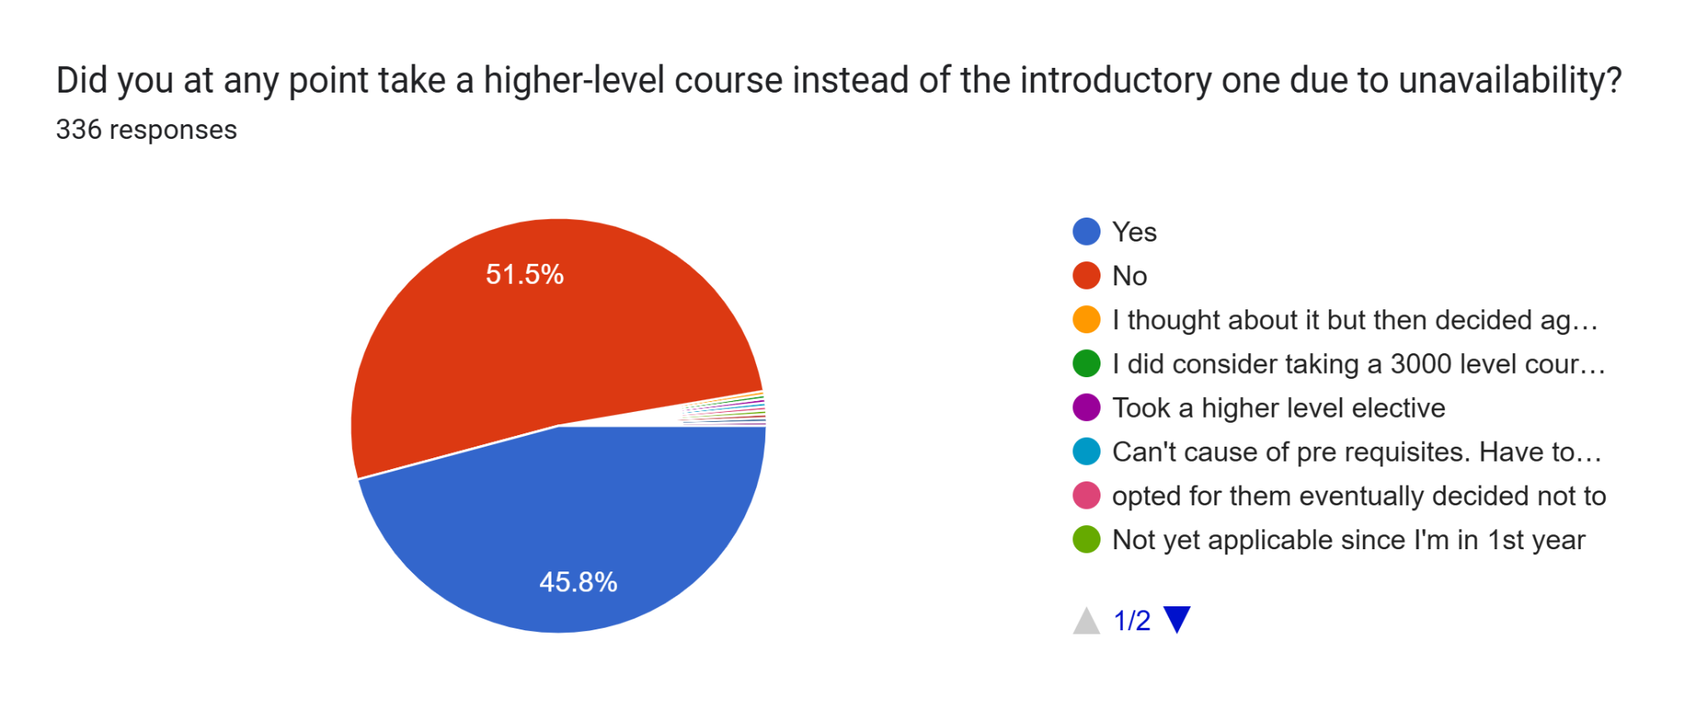
Appendix XI
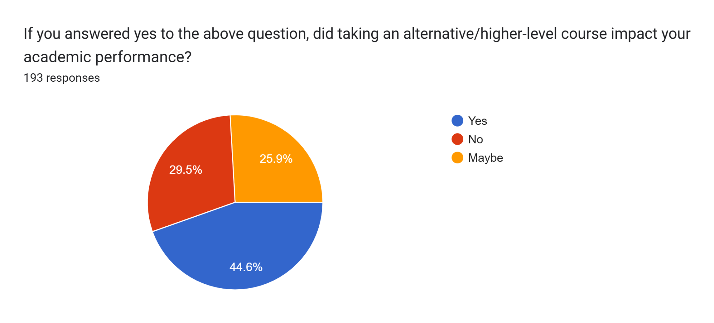
Appendix XII
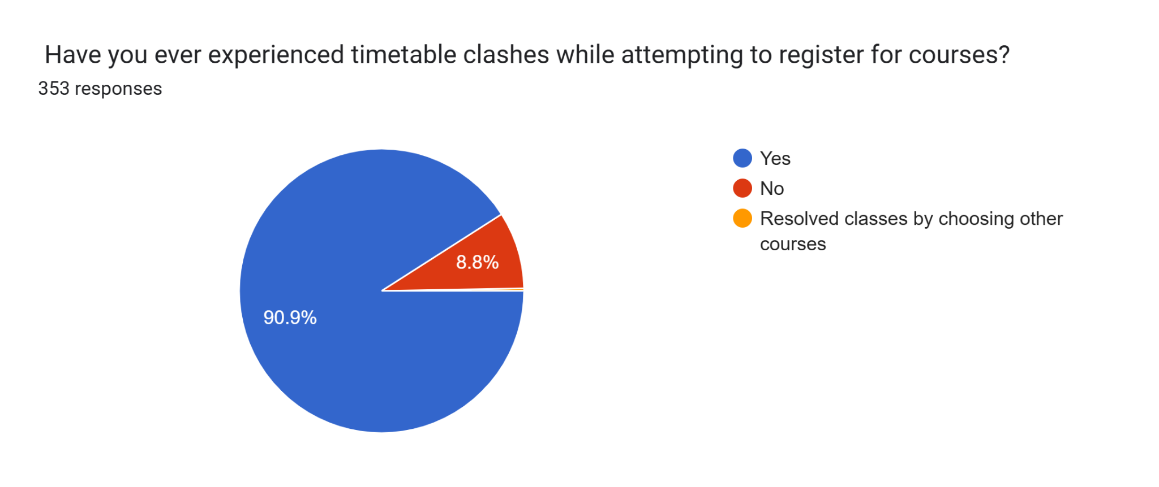
Appendix XIII
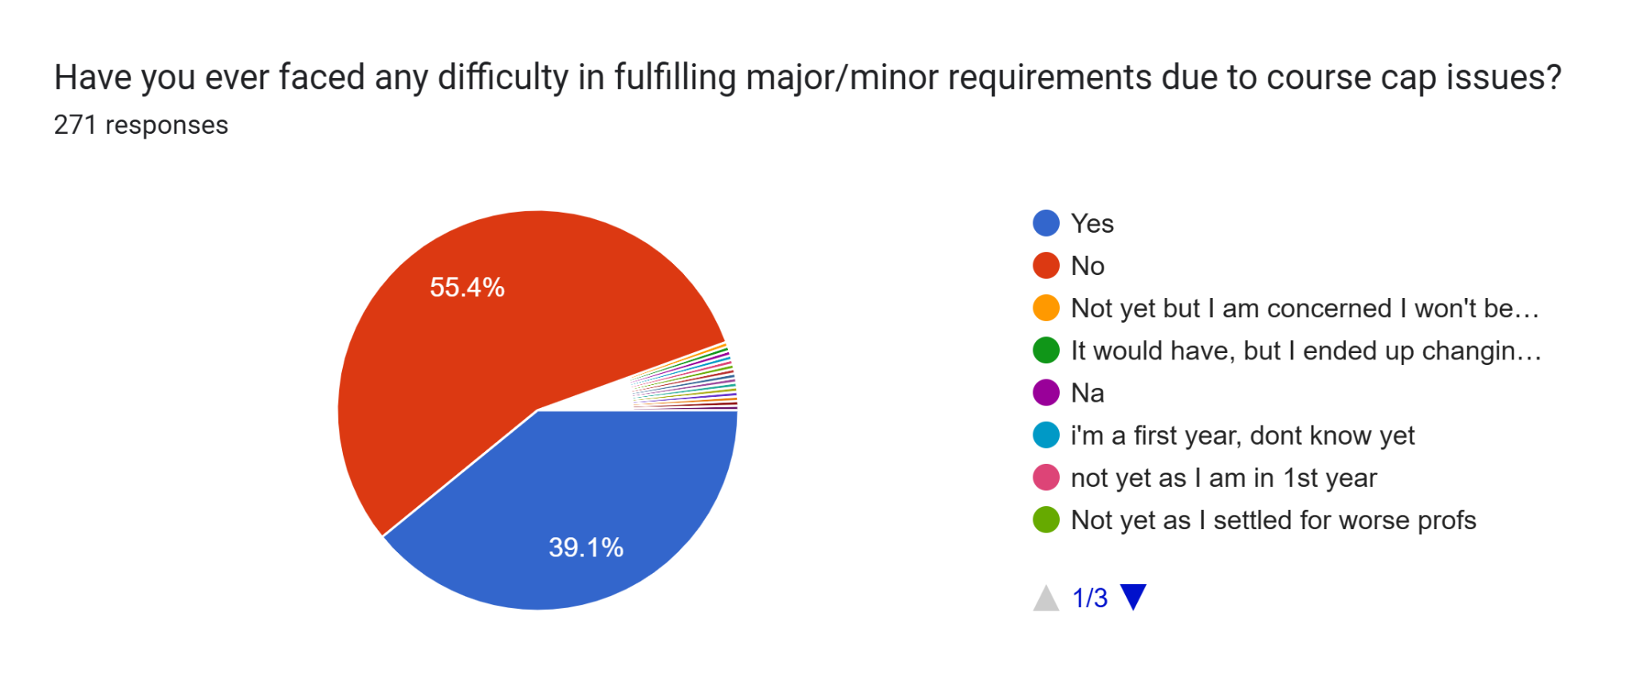

View Appendix II
View Appendix II
View Appendix I

